Maximum Subarray (Brute → Optimized)
class Solution {
public int maxSubArray(int[] nums) {

int currentSum = nums[0];
int maxSum = nums[0];

for (int i = 1; i < nums.length; i++) {

currentSum = Math.max(nums[i], currentSum + nums[i]);

maxSum = Math.max(maxSum, currentSum);
}

return maxSum;
}
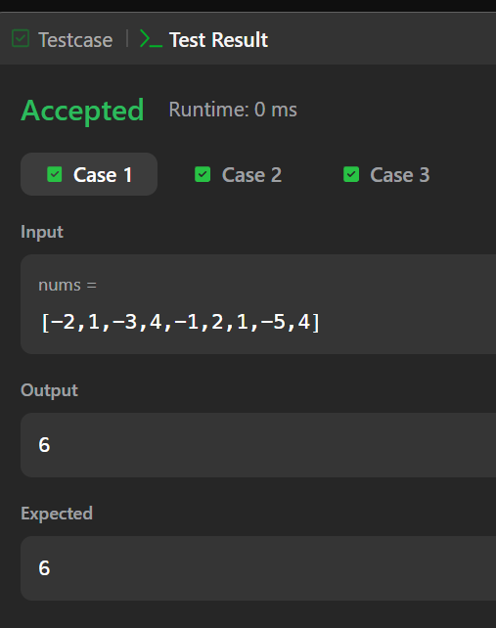
}
Subarray Division

import java.io.*;
import java.util.*;
import java.util.stream.*;

class Result {

public static int birthday(List<Integer> s, int d, int m) {

int count = 0;

for (int i = 0; i <= s.size() - m; i++) {

int sum = 0;

for (int j = i; j < i + m; j++) {
sum += s.get(j);
}

if (sum == d) {
count++;
}
}

return count;
}
}

public class Solution {
public static void main(String[] args) throws IOException {

BufferedReader bufferedReader =
new BufferedReader(new InputStreamReader(System.in));

int n = Integer.parseInt(bufferedReader.readLine().trim());

List<Integer> s = Arrays.stream(
bufferedReader.readLine().trim().split(" ")
)
.map(Integer::parseInt)
.collect(Collectors.toList());

String[] firstMultipleInput =
bufferedReader.readLine().trim().split(" ");

int d = Integer.parseInt(firstMultipleInput[0]);
int m = Integer.parseInt(firstMultipleInput[1]);

int result = Result.birthday(s, d, m);

System.out.println(result);

bufferedReader.close();
}
}
